Experiment XII

**Aim**: Write a program to perform loop unrolling.

Algorithm

1. Start
2. Enter the value of N for which the number of 1s in the binary representation needs to be computed.
3. For loop roll, traverse through the binary representation of the number one digit at a time.
4. The number of iterations is equal to the number of digits in the binary representation.
5. In each iteration, if the current digit is 1, increment the counter.
6. For loop unroll, traverse through the binary representation of the number four digits at a time.
7. In each iteration, count the number of 1s in the compared digits and increment it with the counter.
8. Stop

Output

Enter the value for N: 10

MENU

1. Loop Roll

2. Loop UnRoll

Enter your choice: 1

5

1

Number of iterations: 4

Loop Roll: Count of 1's: 2

Enter the value for N: 10

MENU

1. Loop Roll

2. Loop UnRoll

Enter your choice: 2

Number of iterations: 1

Loop UnRoll: Count of 1's: 2

Screenshot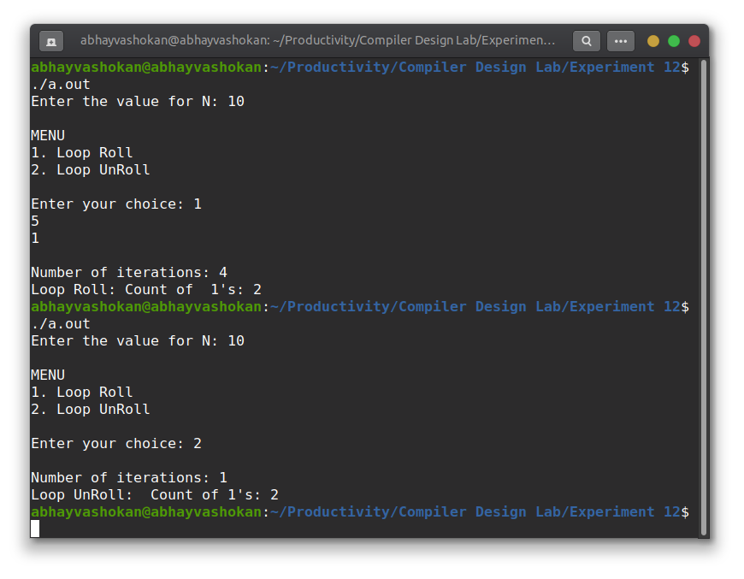

Readme

1. Compile and run the C program using the command

**gcc 2Abhay-P12.c && ./a.out**

2. Enter the number

3. Choose whether to loop roll or unroll

4. The number of iterations wil be obtained as output.

**Result**: Successfully implemented a program to demonstrate loop unrolling.